./

GENESIS - Learning Report MBSE



|  |  |  |  |  |  |
| --- | --- | --- | --- | --- | --- |
| **Ver. Rel. No.** | **Release Date** | **Prepared. By** | **Reviewed By** | **To be Approved** | **Remarks/Revision Details** |
|  | 20/02/2020 | A Joseph Vijay Kumar |  |  |  |
|  |  |  |  |  |  |
|  |  |  |  |  |  |
|  |  |  |  |  |  |
|  |  |  |  |  |  |

**Details**

Contents

Contents 3

1. Subsystems of a Car 5

1.1 Power Train 5

1.2 Chassis 5

1.3 Safety Features 6

1.3.1 Airbags 6

1.3.2 Seat Belts 6

1.3.3 ABS (Anti Lock Braking System) 6

1.3.4 Traction Control 6

1.3.5 Adaptive Headlight 6

1.4 Body control module: 6

1.5 Infotainment System: 7

1.5.1 Features: 7

2. Body Control Module (BCM) 9

2.1 Electronic Control Unit (ECU): 9

2.1.1 INFINEON: 9

2.1.2 RENESAS: 10

2.2 SENSORS 10

2.2.1. Crankshaft Position Sensors: 10

2.2.2. Coolant Temperature Sensors: 10

2.2.3. Intake Air Temperature Sensors: 11

2.2.4. Wheel Speed Sensors: 11

2.2.5. Exhaust Gas Temperature Sensors: 11

2.2.6. Air-Mass Sensors: 11

2.3 ACTUATORS 11

2.3.1 Fuel Pump: 11

2.3.2. Fuel Position Regulator: 11

2.3.3. Idle Speed Actuator: 11

2.3.4. Cooling Fan Control: 11

2.3.5. A/C Compressor Control: 12

2.3.6. Purge Solenoid Valve Control: 12

2.4 Comparative analysis of sensors and actuators 12

2.4.1 Comparative analysis of temperature sensors 12

3. MODEL BASED DESIGN IN TRANSPORTATION: 14

3.1 MBD in powertrain systems: 14

3.2 Electric Motors: 14

3.3 Battery: 14

3.4 Engine: 14

3.5 Transmission and Chassis: 14

4.ALGORITHM 16

Integrated algorithm…………………………………………………………….…………………………………………………………………………18

Output 20

5.Automation script

**Algorithm………………………………………………………………………………………………………………………………………………22**

6.power window 21

Introduction 21

Requirements 21

Implementation 22

Logic Design 22

MIL Design 24

Test Plan 26

**7.Appendix**

MATlab Onramp certificate.………………………………………………………………………………………….90

Simulink Onramp certificate………………………………………………………………………………………….91

Stateflow Onramp certificate…………………………………………………………………………………………92

**Activity-1**

**Subsystems of a Car**

1. **Power Train**

* The powertrain consists of the engine and every component that converts the engine’s power into movement.
* It includes the engine, transmission, driveshaft, differentials and the axle.

                Video: [How powertrain and transmission systems work | ACDelco](https://www.youtube.com/watch?v=SzyswSQD1Sc&ab_channel=LearnEngineering)

1. **Chassis**

* Chassis is a collective term for all the parts of a vehicle except the body work. Every major part of a vehicle is collectively called chassis. It includes wheels, brakes, suspension systems, axles, engine, etc.
* Broadly classified into 3 main types-Conventional , Semi-Forward and Full forward chassis.
  + Conventional
    - Engine in front of driver
    - Full space unutilized
    - Specific portion in front of the car is invisible to driver
  + Semi-Forward
    - Half portion in front of driver , rest half beneath
    - Half space is left unutilized
    - Small portion is invisible to the driver
  + Full-Forward
    - Whole of the engine is beneath the driver’s position
    - All of the occupied space is utilized
    - Road in front is clearly visible to driver

  Reference Video: [AUTOMOBILE CHASSIS & it's types](https://www.youtube.com/watch?v=I0kToZLtaOQ)

1. **Safety Features**

* **Airbags:** The airbag is a vehicle safety device. It is a restraining device designed to inflate rapidly during an automobile collision. It prevents the driver and passenger from striking the steering wheel or a window.
  + **Video:** [How Do Airbags Work?](https://www.youtube.com/watch?v=Y2sjYOGSV7E&ab_channel=Reactions)
* **Seat Belts:** A seat belt is a vehicle safety device designed to secure the driver or a passenger of a vehicle against harmful movement that may result during a collision or a sudden stop.
  + Video: [How do seat belts work? | Skill-Lync](https://www.youtube.com/watch?v=be3KPHjYbc8&ab_channel=SkillLync)
* **ABS(Anti Lock Braking System):** ABS operates by preventing the wheels from locking up during braking, thereby maintaining tractive contact with the road surface and allowing the driver to maintain more control over the vehicle.
  + Video: [Understanding Anti-lock Braking System (ABS)](https://www.youtube.com/watch?v=98DXe3uKwfc&ab_channel=LearnEngineering)
* **Traction Control:** A traction control system (TCS), also known as ASR, is typically (but not necessarily) a secondary function of the electronic stability control (ESC) on production motor vehicles, designed to prevent loss of traction (i.e., wheelspin) of the driven road wheels. TCS is activated when throttle input and engine power and torque transfer are mismatched to the road surface conditions.
  + Video: [How does Traction Control System work? | Skill-Lync](https://www.youtube.com/watch?v=C8I0f07yYKI&ab_channel=SkillLync)
* **Adaptive Headlight:** Headlights improve vision after the sun sets, and adaptive headlights help take visibility a step farther. These systems use sensors that monitor the car’s elevation to illuminate the road more effectively while also reducing glare for oncoming drivers. By improving visibility and making your car easier for other driver’s to see, adaptive headlights are an important safety feature.
  + Video: [Adaptive Headlights](https://www.youtube.com/watch?v=RQPTeUnuIGY&ab_channel=ToyotaMotorCorporation)

1. **Body control module:**

* The automotive central body control module (BCM) is a processor-based power distribution center that supervises and controls functions related to the car body such as lights, windows, security, door locks and access control, and various comfort controls.
* The central BCM also operates as a gateway for bus and network interfaces to interact with remote electronic control units (ECU) for other systems.
* Control of various loads comes directly from remote ECU via CAN/LIN communication or directly from the central body module. The BCM does not control any engine-related function.
* A typical Body Control Module ECU consists of a microprocessor to control the various functions of vehicle’s body electronics (power window, wiper, side-view mirrors and more).
* **Input Devices**: Devices that feed data to the body control module and  include sensors (potentiometers, variable resistors, magnetic pickup, etc.)
* **Output Devices**: Devices that are tasked with generating a response to the signal received from the input devices (relays and solenoids are typical examples of output devices in the context of BCM)

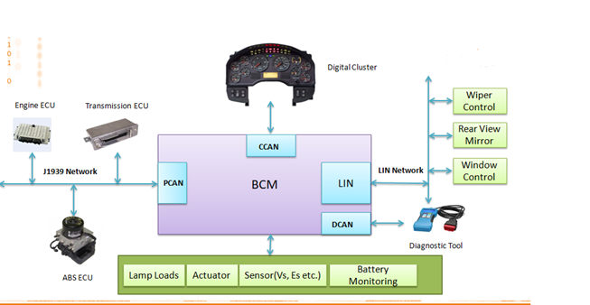

The above Body Control Module block diagram indicates how the unit is connected to various input and output devices and the communication flow between these components.

**5. Infotainment System:**

* A vehicle infotainment system connect with smart automotive technologies such as smartphones, sensors, telematics devices, and others to provide a safe, pleasant, and productive driving experience.
* It is a combination of system that delivers entertainment and information to the driver and passengers. They do it using audio and video interfaces, touch screen displays, button panels, voice commands, and many other features.

**Features of car Infotainment system:**

**Head-up display:**

* A head-up display is a transparent display that shows data without requiring drivers to look away from the road with the head positioned up and looking forward, instead of angled down.
* It increases safety by allowing users to see everything they need without getting their eyes off the road.

**Smartphone pairing:**

* Users can pair smartphones with automotive systems to Bluetooth connectivity. By doing that, users can access phone features through the infotainment system.
* The users can manage incoming, outgoing, and conference calls, view their contact list, see call logs or even read and send emails or SMS.

**Multi-standard radio reception:**

* Radio System include AM and FM digital radio which users can adjust to automatic or manual tuning. Users can then scan available radio stations easily.

**Multimedia:**

* Car infotainment systems use Bluetooth, HDMI cable, and USB to transfer audio and video content to display screens, headphones, and speakers. These solutions can easily display pictures and videos, and they support a broad range of audio formats.
* Car infotainment systems support features that help users make the most of their vehicles and improve safety. These features include parking assistance, climate control in the vehicle, daytime running lights (DRL) indicators, and voice assistants that control system functions.

**Activity-2**

**Features of Body Control Module (BCM):**

High end BCM has more number of **communication** bus like CAN transceiver, LIN transceiver, Flexray transceiver to communicate at a faster rate with critical body functions. Critical body functions include remote keyless entry, panoramic **power** sunroof, and automatic trunk opener.

**The main Functions of BCM are**

* Energy management systems.
* Alarms.
* Immobilizers.
* Access/driver authorization systems.
* Advanced driver assistance systems.
* Power windows.

**Electronic Control Unit(ECU):**

Electronic control units in vehicles are constantly becoming more complex and continue to increase in number. There are approximately 100 ECUs in a typical modern car, aimed at reinforcing overall performance by improving human-machine interfaces, telematics, engine function, battery life, and other things. The complexity of ECUs is a major factor underlying the need to develop integrated body control module software.

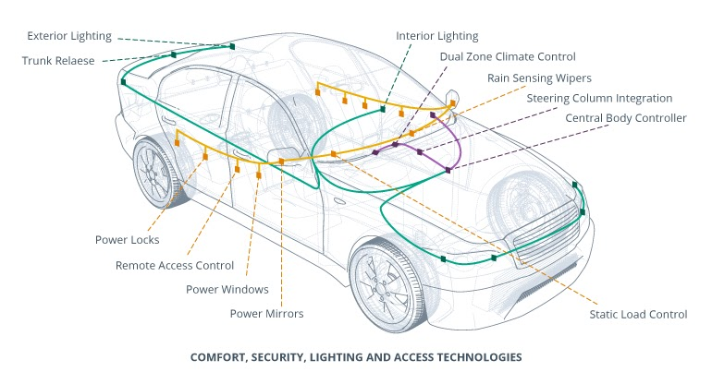

The above figure shows us In-car electronics controlled via BCM

**INFINEON:**

• Supply of the module with Infineon Supply IC&#39; s out of the OPTI REG-Linear, OPTIREG-Switcher, and OPTIREG-SB (System Basis Chip with Integrated drop voltage regulator or DCDC) families.

• Actuation of the vehicle function loads with Power ICs of the PROFET, Power PROFET, SPOC, SPIDER, HITFET, LITIX, Nova lithic, Multi MOSFET Driver and MOSFET Families.

• Sensing with pressure sensors of the XENSIV Family (and monitoring in the BCM) or integrated into the Power ICs. For car access, Infineon offers Transceiver and Receiver in Remote Keyless Entry (RKE) and Passive Keyless Entry (PKE).

• Control of the whole Vehicle Body with Traveo II and AURIX Families of Microcontroller.

• Communication with other car functions via the vehicle bus system by LIN or CAN Transceiver Families or integrated with Supply into the System Basis Chip Family.

• The number of body functions has increased, but also their variants of these functions required for different vehicle trim levels.  For example; one module may support seat movement to bidirectional lift, slide, recline and adjust lumbar and headrests, as well as heating and cooling but this module may only include some of these for a low-end vehicle.  This creates a need for flexibility and scalability of product families to create a BCM platform that can accommodate easy variants and changes throughout the design to years after SOP.

• Infineon’s Power Switch families PROPHET, SPOC, and SPIDER have the most scalable portfolio of protected switches in the market to enable this flexibility in hardware and software.

**RENESAS**:

A body control module (BCM) integrates several functions, including various lights      and door locks. It has a gateway function for communication with a CAN or LIN. Such a unit requires components with CAN/LIN network support, a selection of package sizes and memory capacities to match a variety of system scales, low EMI to prevent radio noise interference with vehicle wiring systems, and low current consumption to reduce battery drain when in standby status.

Renesas offers kit solutions that include microcontrollers (MCUs), analog devices and power devices for optimized body control. We also supply power devices and LED headlight controllers with overcurrent detection and diagnostic functions, enabling low current consumption in LED headlight units, which have become increasingly popular in recent years.

Electronic control units (ECUs) can now be found everywhere in automobiles, from power windows and airbags to lamps, mirrors, doors, and seats. Due to this trend, the burden on software development for ECUs has also increased. Renesas offers a wide variety of products for automotive bodies, including MCUs, SoCs, sensors and power management devices.

**Sensors**

**1.** **CRANKSHAFT POSITION SENSORs**: The function of crankshaft sensors is to measure the crankshaft's speed and position. They are most commonly installed near to the flywheel ring gear.

**2.** **COOLANT TEMPERATURE SENSORs:**Coolant temperature sensors are used by the fuel management system to detect the engine's operating temperature. Depending on the sensor information, the control unit adapts the injection time and firing angle to the operating conditions.

**3.** **INTAKE-AIR TEMPERATURE SENSORs:** The intake-air temperature sensor determines the temperature in the suction pipe and forwards the voltage signals arising from the temperature to the control unit.

**4.** **WHEEL SPEED SENSORS:** The wheel speed sensor was initially used to replace the mechanical linkage from the wheels to the [speedometer](https://en.wikipedia.org/wiki/Speedometer), eliminating cable breakage and simplifying the gauge construction by eliminating moving parts.

# 5. EXHAUST GAS TEMPERATURE SENSOR: The exhaust gas temperature sensor detects the temperature, for example, in front of the catalytic converter or diesel particulate filter and sends this as a voltage signal to the engine control unit.

# 6. AIR-MASS SENSOR: The air-mass sensor calculates the intake air mass in internal combustion engines. The engine control requires this variable in order to control a wide range of functions.

# 

# 

# ACTUATORS

# 1. FUEL PUMP: Fuel Pump is powered from the Vehicle battery and connected to the engine ECU, to give the engine the fuel at the right pressure suitable for its work.

**2.** **FUEL PRESSURE REGULATOR:** Injection rate through injector depends on injection pressure, injection time and orifice size. Therefore, in order to control fuel injection rate by means of current connecting time for an injector with spray hole size fixed, injection pressure shall remain constant for any varied pressure at intake manifold.

**3.** [**Idle Speed Actuator**](http://www.micro-tronik.com/learning/technical-information/automotive/repair-basics/actuators/idle-speed-actuator/)**:** ISA (Idle Speed Actuator) is installed at throttle body of engine and control air intake rate into engine depending on ECU signal in order to control idle rp Idling speed is controlled relying on a number of parameters including actual engine rpm, coolant temperature, air-conditioning system and headlamp operation status, etc.

**4.** **COOLING FAN CONTROL:** In order to maximize cooling efficiency and minimize cooling fan motor drive current, radiator fan and condenser fan speeds are controlled using three speed modes such as low, medium, and high speed, on the basis of coolant temperature, car speed, air conditioning switch signal, and conditioning compressor operation signal.

**5.** **A/C COMPRESSOR CONTROL:** A/C Compressor Control Outline A/C Compressor Control is used when accelerating or engine load is instantly increased greatly, in order to improve engine acceleration by temporarily turning off A/C compressor.

**6.** **PURGE SOLENOID VALVE CONTROL:** A vehicle generates evaporated gas at fuel system such as fuel tank, and HC is the main substance of the gas. Fuel tank requires venting system to avoid pressure rising in the tank when raised temperature generates volume expansion, and there after resulting vacuum pressure. In addition, vapor gas control system is required to prevent fuel vapor from being discharged into atmosphere.

**Comparative analysis of sensors and actuators**

**Comparative analysis of temperature sensors**

|  |  |
| --- | --- |
| **ADT7410** | **LM95172** |
| * Temperature range: −55°C to +150°C * 16-bit temperature resolution: 0.0078°C * I2C-compatible interface * Voltage range: 2.7 V to 5.5 V * APPLICATIONS   Medical equipment  Environmental control systems  Computer thermal monitoring  Thermal protection  Industrial process control  Power system monitors  Hand-held applications | * Temperature Range:−40°C to +200°C * 16-Bit (0.0078125°C LSB) Temperature Resolution * SPI and MICROWIRE Bus Interface * Analog and Digital Supply Voltage 3.0V to 5.5V. * APPLICATIONS   High Temperature Test Equipment  Geothermal Instrumentation  Industrial Motors, Gear Boxes  Industrial Power Controllers  Automotive High Temperature applications |

**Comparative analysis of actuators**

|  |  |
| --- | --- |
| **L293** | **L298** |
| * Internal ESD Protection * Wide Supply-Voltage Range: 4.5 V to 36 V * Maximum junction temperature   150 C   * Applications   Latching Relay Drivers  Stepper Motor Drivers  DC Motor Drivers | * OVERTEMPERATURE PROTECTION * OPERATING SUPPLY VOLTAGE UP TO 46 V * Junction Operating Temperature: -25 to 130 C * Applications   bidirectional DC motor control |

**Activity-3**

**How model based design is applicable in transportation:**

Model-based design (MBD) is a mathematical and visual method of addressing problems associated with designing complex control,[signal processing and communication systems. It is used in many industrial equipment, aerospace and automotive applications. Model-based design is a methodology applied in designing embedded software.

**MBD in powertrain systems:**

* System analysis and design for optimum performance
* Control function development
* Early V&V of control function
* Auto-coding
* Integration with standard function and V&V

**Electric Motors:**

* Modelled as an electromechanical energy conversion device where electrical power equals mechanical power. The model allows the component to operate as a motor or a generator.

**Battery:**

* Modelled as a voltage source in series with a resistance. The resistance and open circuit voltage of the battery are functions of temperature and battery state of charge. The battery state of charge is calculated by integrating the battery current.

**Engine:**

* Modelled as a device that converts fuel energy into mechanical energy. The output torque is equal to the throttle position times the available torque. The available torque is determined by a look-up table that describes the maximum available torque as a function of engine rpm. Fuel consumption is calculated by integrating the output of a two-dimensional look-up table that specifies the consumption rate as a function of rpm and throttle position.

**Transmission and Chassis:**

* The powertrain is constructed using parts available in The Math Works Sim Driveline. This product has components for gears, tires, differentials, clutches, and more. In the series model, the electric motor is tied to the rear wheels through a differential. The vehicle acceleration/deceleration is modelled using the Sim Driveline Vehicle Solver block. This block takes a force input and calculates vehicle speed based on the road incline, vehicle mass, and the drag coefficient. Although students could generate some of these component models in the class, the Sim Driveline components are used to allow more time for system and controller development.

**Activity-4**

**ALGORITHM :**

**Activity-5**

**Automation Script:**

**Activity-6**

**BCM Sub-system – Power Window**

**Introduction: Power windows** or **electric windows** are [automobile](https://en.wikipedia.org/wiki/Automobile) [windows](https://en.wikipedia.org/wiki/Window) which can be raised and lowered by pressing a button or [switch](https://en.wikipedia.org/wiki/Switch), as opposed to using a [crank handle](https://en.wikipedia.org/wiki/Crank_(mechanism)). Power windows are usually inoperable when the car is not running. This is primarily a security feature. It would be a simple thing to allow electric power windows to be operable when the ignition is turned off, however it would also make the car much easier to steal. Some systems offer the compromise of leaving power applied to the windows until a passenger door is opened at which time the window power is removed.

**Requirements:**

Input:

Three inputs from driver for all four car windows

1.Up (Lift the button up)

2.Down (Push the button down)

3.Neutral (Button stays at neutral position)

Three inputs from each passenger for their respective windows

1.Up (Lift the button up)

2.Down (Push the button down)

3.Neutral (Button stays at neutral position)

Output:

There are three different outputs from either driver or passenger

1.Up- Move the window upwards

2.Down-Move the window downwards

3.Neutral-Window will stay at its same position

**Simulink Blocks Required:**

Logical model:

Rotary switch(3-Modes)-7

Constant blocks-7

If blocks-4

If action blocks-18

Merge blocks-4

Display-4

MIL Model:

Signal Builder-4

If blocks-4

If action blocks-18

Merge blocks-4

Scope-4

**Test plan:**

**Low level test plan:**

|  |  |  |  |  |
| --- | --- | --- | --- | --- |
| SL No. | Driver input | Passenger input | Expected Result | Actual Result |
| 01 | Up | Up/Down/Neutral | Should pass the signal from driver input- move Up | Window-move Up |
| 02 | Down | Up/Down/Neutral | Should pass the signal from driver input- move Down | Window-Move Down |
| 03 | Neutral | Up | Should pass the signal from passenger input-move Up | Window-Move Up |
| 04 | Neutral | Down | Should pass the signal from passenger input-move Down | Window-Move Down |
| 05 | Neutral | Neutral | No signal passed from either of the user-Stay at same position | Window-Stay at same position |

**Implementation:**

**Logical model:**

**pwr_window_subsys_2018**

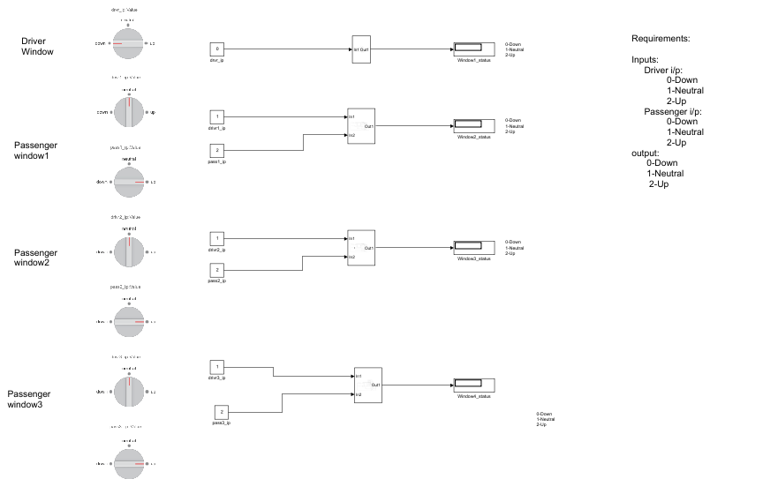

**A JOSEPH VIJAY KUMAR**

20-Dec-2020 22:53:17

**Table of Contents**

Model - pwr_window_subsys_2018

System - pwr_window_subsys_2018

System - pwr_window_subsys_2018/Subsystem

System - pwr_window_subsys_2018/Subsystem/If Action Subsystem

System - pwr_window_subsys_2018/Subsystem/If Action Subsystem1

System - pwr_window_subsys_2018/Subsystem/If Action Subsystem2

System - pwr_window_subsys_2018/Subsystem/If Action Subsystem3

System - pwr_window_subsys_2018/Subsystem/If Action Subsystem4

System - pwr_window_subsys_2018/Subsystem1

System - pwr_window_subsys_2018/Subsystem1/If Action Subsystem

System - pwr_window_subsys_2018/Subsystem1/If Action Subsystem1

System - pwr_window_subsys_2018/Subsystem1/If Action Subsystem2

System - pwr_window_subsys_2018/Subsystem1/If Action Subsystem3

System - pwr_window_subsys_2018/Subsystem1/If Action Subsystem4

System - pwr_window_subsys_2018/Subsystem2

System - pwr_window_subsys_2018/Subsystem2/If Action Subsystem

System - pwr_window_subsys_2018/Subsystem2/If Action Subsystem1

System - pwr_window_subsys_2018/Subsystem2/If Action Subsystem2

System - pwr_window_subsys_2018/Subsystem3

System - pwr_window_subsys_2018/Subsystem3/If Action Subsystem

System - pwr_window_subsys_2018/Subsystem3/If Action Subsystem1

System - pwr_window_subsys_2018/Subsystem3/If Action Subsystem2

System - pwr_window_subsys_2018/Subsystem3/If Action Subsystem3

System - pwr_window_subsys_2018/Subsystem3/If Action Subsystem4

Appendix

**List of Tables**

1. Constant Block Properties

2. Display Block Properties

3. RotarySwitchBlock Block Properties

4. Constant Block Properties

5. If Block Properties

6. Inport Block Properties

7. Merge Block Properties

8. Outport Block Properties

9. ActionPort Block Properties

10. Inport Block Properties

11. Outport Block Properties

12. ActionPort Block Properties

13. Inport Block Properties

14. Outport Block Properties

15. ActionPort Block Properties

16. Inport Block Properties

17. Outport Block Properties

18. ActionPort Block Properties

19. Inport Block Properties

20. Outport Block Properties

21. ActionPort Block Properties

22. Inport Block Properties

23. Outport Block Properties

24. If Block Properties

25. Inport Block Properties

26. Merge Block Properties

27. Outport Block Properties

28. ActionPort Block Properties

29. Inport Block Properties

30. Outport Block Properties

31. ActionPort Block Properties

32. Inport Block Properties

33. Outport Block Properties

34. ActionPort Block Properties

35. Inport Block Properties

36. Outport Block Properties

37. ActionPort Block Properties

38. Inport Block Properties

39. Outport Block Properties

40. ActionPort Block Properties

41. Inport Block Properties

42. Outport Block Properties

43. If Block Properties

44. Inport Block Properties

45. Merge Block Properties

46. Outport Block Properties

47. ActionPort Block Properties

48. Inport Block Properties

49. Outport Block Properties

50. ActionPort Block Properties

51. Inport Block Properties

52. Outport Block Properties

53. ActionPort Block Properties

54. Inport Block Properties

55. Outport Block Properties

56. Constant Block Properties

57. If Block Properties

58. Inport Block Properties

59. Merge Block Properties

60. Outport Block Properties

61. ActionPort Block Properties

62. Inport Block Properties

63. Outport Block Properties

64. ActionPort Block Properties

65. Inport Block Properties

66. Outport Block Properties

67. ActionPort Block Properties

68. Inport Block Properties

69. Outport Block Properties

70. ActionPort Block Properties

71. Inport Block Properties

72. Outport Block Properties

73. ActionPort Block Properties

74. Inport Block Properties

75. Outport Block Properties

76. Block Type Count

**Model - pwr_window_subsys_2018**

**Full Model Hierarchy**

1. pwr_window_subsys_2018
   1. Subsystem
      1. If Action Subsystem
      2. If Action Subsystem1
      3. If Action Subsystem2
      4. If Action Subsystem3
      5. If Action Subsystem4
   2. Subsystem1
      1. If Action Subsystem
      2. If Action Subsystem1
      3. If Action Subsystem2
      4. If Action Subsystem3
      5. If Action Subsystem4
   3. Subsystem2
      1. If Action Subsystem
      2. If Action Subsystem1
      3. If Action Subsystem2
   4. Subsystem3
      1. If Action Subsystem
      2. If Action Subsystem1
      3. If Action Subsystem2
      4. If Action Subsystem3
      5. If Action Subsystem4

| **Simulation Parameter** | **Value** |
| --- | --- |
| Solver | VariableStepAuto |
| RelTol | 1e-3 |
| Refine | 1 |
| MaxOrder | 5 |
| ZeroCross | on |

*[more info]*

**System - pwr_window_subsys_2018**



**Table 1. Constant Block Properties**

| **Name** | **Value** | **Out Data Type Str** | **Lock Scale** | **Sample Time** | **Frame Period** |
| --- | --- | --- | --- | --- | --- |
| drivr1_ip | 1 | Inherit: Inherit from 'Constant value' | off | inf | inf |
| drivr2_ip | 1 | Inherit: Inherit from 'Constant value' | off | inf | inf |
| drivr3_ip | 1 | Inherit: Inherit from 'Constant value' | off | inf | inf |
| drvr_ip | 0 | Inherit: Inherit from 'Constant value' | off | inf | inf |
| pass1_ip | 2 | Inherit: Inherit from 'Constant value' | off | inf | inf |
| pass2_ip | 2 | Inherit: Inherit from 'Constant value' | off | inf | inf |
| pass3_ip | 2 | Inherit: Inherit from 'Constant value' | off | inf | inf |

**Table 2. Display Block Properties**

| **Name** | **Format** | **Decimation** | **Floating** |
| --- | --- | --- | --- |
| Window1_status | short | 1 | off |
| Window2_status | short | 1 | off |
| Window3_status | short | 1 | off |
| Window4_status | short | 1 | off |

**Table 3. RotarySwitchBlock Block Properties**

| **Name** | **Label Position** | **Binding** | **Show Initial Text** | **States** |
| --- | --- | --- | --- | --- |
| Rotary Switch | Top | < Simulink.HMI.ParamSourceInfo> | on | [3x1 struct w/ fields: Value, Label] |
| Rotary Switch1 | Top | < Simulink.HMI.ParamSourceInfo> | on | [3x1 struct w/ fields: Value, Label] |
| Rotary Switch2 | Top | < Simulink.HMI.ParamSourceInfo> | on | [3x1 struct w/ fields: Value, Label] |
| Rotary Switch3 | Top | < Simulink.HMI.ParamSourceInfo> | on | [3x1 struct w/ fields: Value, Label] |
| Rotary Switch4 | Top | < Simulink.HMI.ParamSourceInfo> | on | [3x1 struct w/ fields: Value, Label] |
| Rotary Switch5 | Top | < Simulink.HMI.ParamSourceInfo> | on | [3x1 struct w/ fields: Value, Label] |
| Rotary Switch6 | Top | < Simulink.HMI.ParamSourceInfo> | on | [3x1 struct w/ fields: Value, Label] |

**System -****pwr_window_subsys_2018****/Subsystem**

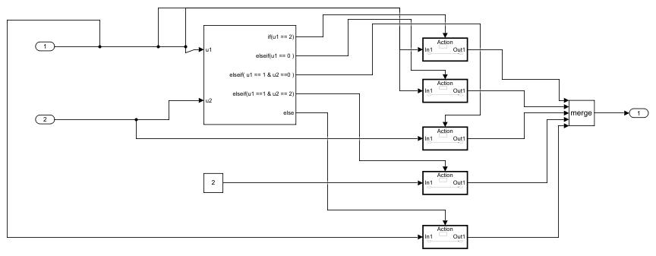

**Table 4. Constant Block Properties**

| **Name** | **Value** | **Out Data Type Str** | **Lock Scale** | **Sample Time** | **Frame Period** |
| --- | --- | --- | --- | --- | --- |
| Constant | 2 | Inherit: Inherit from 'Constant value' | off | inf | inf |

**Table 5. If Block Properties**

| **Name** | **Num Inputs** | **If Expression** | **Else If Expressions** | **Show Else** | **Zero Cross** |
| --- | --- | --- | --- | --- | --- |
| If | 2 | u1 == 2 | u1 == 0 , u1 == 1 & u2 ==0 ,u1 ==1 & u2 == 2 | on | on |

**Table 6. Inport Block Properties**

| **Name** | **Port** | **Defined In Blk** |
| --- | --- | --- |
| In1 | 1 | drivr1_ip |
| In2 | 2 | pass1_ip |

**Table 7. Merge Block Properties**

| **Name** | **Inputs** | **Allow Unequal Input Port Widths** |
| --- | --- | --- |
| Merge | 5 | off |

**Table 8. Outport Block Properties**

| **Name** | **Port** | **Storage Class** | **Icon Display** | **Lock Scale** | **Unit** | **Var Size Sig** | **Signal Type** | **Ensure Outport Is Virtual** | **Source Of Initial Output Value** | **Output When Disabled** | **Must Resolve To Signal Object** | **Output When Un Connected** | **Output When Unconnected Value** | **Vector Params As 1DFor Out When Unconnected** | **Used By Blk** |
| --- | --- | --- | --- | --- | --- | --- | --- | --- | --- | --- | --- | --- | --- | --- | --- |
| Out1 | 1 | Auto | Port number | off | inherit | Inherit | auto | off | Dialog | held | off | off | 0 | off | Window2_status |

**System -****pwr_window_subsys_2018****/****Subsystem****/If Action Subsystem**

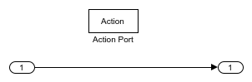

**Table 9. ActionPort Block Properties**

| **Name** | **Initialize States** | **Propagate Var Size** |
| --- | --- | --- |
| Action Port | held | Only when execution is resumed |

**Table 10. Inport Block Properties**

| **Name** | **Port** | **Defined In Blk** |
| --- | --- | --- |
| In1 | 1 | drivr1_ip |

**Table 11. Outport Block Properties**

| **Name** | **Port** | **Storage Class** | **Icon Display** | **Lock Scale** | **Unit** | **Var Size Sig** | **Signal Type** | **Ensure Outport Is Virtual** | **Source Of Initial Output Value** | **Output When Disabled** | **Must Resolve To Signal Object** | **Output When Un Connected** | **Output When Unconnected Value** | **Vector Params As 1DFor Out When Unconnected** | **Used By Blk** |
| --- | --- | --- | --- | --- | --- | --- | --- | --- | --- | --- | --- | --- | --- | --- | --- |
| Out1 | 1 | Auto | Port number | off | inherit | Inherit | auto | off | Dialog | held | off | off | 0 | off | Merge |

**System -****pwr_window_subsys_2018****/****Subsystem****/If Action Subsystem1**



**Table 12. ActionPort Block Properties**

| **Name** | **Initialize States** | **Propagate Var Size** |
| --- | --- | --- |
| Action Port | held | Only when execution is resumed |

**Table 13. Inport Block Properties**

| **Name** | **Port** | **Defined In Blk** |
| --- | --- | --- |
| In1 | 1 | drivr1_ip |

**Table 14. Outport Block Properties**

| **Name** | **Port** | **Storage Class** | **Icon Display** | **Lock Scale** | **Unit** | **Var Size Sig** | **Signal Type** | **Ensure Outport Is Virtual** | **Source Of Initial Output Value** | **Output When Disabled** | **Must Resolve To Signal Object** | **Output When Un Connected** | **Output When Unconnected Value** | **Vector Params As 1DFor Out When Unconnected** | **Used By Blk** |
| --- | --- | --- | --- | --- | --- | --- | --- | --- | --- | --- | --- | --- | --- | --- | --- |
| Out1 | 1 | Auto | Port number | off | inherit | Inherit | auto | off | Dialog | held | off | off | 0 | off | Merge |

**System -****pwr_window_subsys_2018****/****Subsystem****/If Action Subsystem2**



**Table 15. ActionPort Block Properties**

| **Name** | **Initialize States** | **Propagate Var Size** |
| --- | --- | --- |
| Action Port | held | Only when execution is resumed |

**Table 16. Inport Block Properties**

| **Name** | **Port** | **Defined In Blk** |
| --- | --- | --- |
| In1 | 1 | Constant |

**Table 17. Outport Block Properties**

| **Name** | **Port** | **Storage Class** | **Icon Display** | **Lock Scale** | **Unit** | **Var Size Sig** | **Signal Type** | **Ensure Outport Is Virtual** | **Source Of Initial Output Value** | **Output When Disabled** | **Must Resolve To Signal Object** | **Output When Un Connected** | **Output When Unconnected Value** | **Vector Params As 1DFor Out When Unconnected** | **Used By Blk** |
| --- | --- | --- | --- | --- | --- | --- | --- | --- | --- | --- | --- | --- | --- | --- | --- |
| Out1 | 1 | Auto | Port number | off | inherit | Inherit | auto | off | Dialog | held | off | off | 0 | on | Merge |

**System -****pwr_window_subsys_2018****/****Subsystem****/If Action Subsystem3**



**Table 18. ActionPort Block Properties**

| **Name** | **Initialize States** | **Propagate Var Size** |
| --- | --- | --- |
| Action Port | held | Only when execution is resumed |

**Table 19. Inport Block Properties**

| **Name** | **Port** | **Defined In Blk** |
| --- | --- | --- |
| In1 | 1 | pass1_ip |

**Table 20. Outport Block Properties**

| **Name** | **Port** | **Storage Class** | **Icon Display** | **Lock Scale** | **Unit** | **Var Size Sig** | **Signal Type** | **Ensure Outport Is Virtual** | **Source Of Initial Output Value** | **Output When Disabled** | **Must Resolve To Signal Object** | **Output When Un Connected** | **Output When Unconnected Value** | **Vector Params As 1DFor Out When Unconnected** | **Used By Blk** |
| --- | --- | --- | --- | --- | --- | --- | --- | --- | --- | --- | --- | --- | --- | --- | --- |
| Out1 | 1 | Auto | Port number | off | inherit | Inherit | auto | off | Dialog | held | off | off | 0 | off | Merge |

**System -****pwr_window_subsys_2018****/****Subsystem****/If Action Subsystem4**



**Table 21. ActionPort Block Properties**

| **Name** | **Initialize States** | **Propagate Var Size** |
| --- | --- | --- |
| Action Port | held | Only when execution is resumed |

**Table 22. Inport Block Properties**

| **Name** | **Port** | **Defined In Blk** |
| --- | --- | --- |
| In1 | 1 | drivr1_ip |

**Table 23. Outport Block Properties**

| **Name** | **Port** | **Storage Class** | **Icon Display** | **Lock Scale** | **Unit** | **Var Size Sig** | **Signal Type** | **Ensure Outport Is Virtual** | **Source Of Initial Output Value** | **Output When Disabled** | **Must Resolve To Signal Object** | **Output When Un Connected** | **Output When Unconnected Value** | **Vector Params As 1DFor Out When Unconnected** | **Used By Blk** |
| --- | --- | --- | --- | --- | --- | --- | --- | --- | --- | --- | --- | --- | --- | --- | --- |
| Out1 | 1 | Auto | Port number | off | inherit | Inherit | auto | off | Dialog | held | off | off | 0 | on | Merge |

**System -****pwr_window_subsys_2018****/Subsystem1**

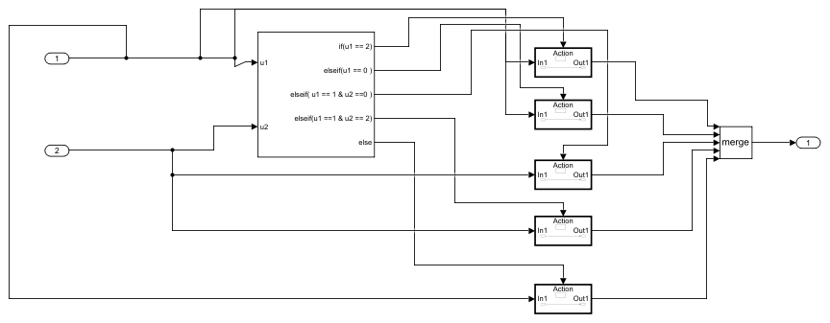

**Table 24. If Block Properties**

| **Name** | **Num Inputs** | **If Expression** | **Else If Expressions** | **Show Else** | **Zero Cross** |
| --- | --- | --- | --- | --- | --- |
| If | 2 | u1 == 2 | u1 == 0 , u1 == 1 & u2 ==0 ,u1 ==1 & u2 == 2 | on | on |

**Table 25. Inport Block Properties**

| **Name** | **Port** | **Defined In Blk** |
| --- | --- | --- |
| In1 | 1 | drivr2_ip |
| In2 | 2 | pass2_ip |

**Table 26. Merge Block Properties**

| **Name** | **Inputs** | **Allow Unequal Input Port Widths** |
| --- | --- | --- |
| Merge | 5 | off |

**Table 27. Outport Block Properties**

| **Name** | **Port** | **Storage Class** | **Icon Display** | **Lock Scale** | **Unit** | **Var Size Sig** | **Signal Type** | **Ensure Outport Is Virtual** | **Source Of Initial Output Value** | **Output When Disabled** | **Must Resolve To Signal Object** | **Output When Un Connected** | **Output When Unconnected Value** | **Vector Params As 1DFor Out When Unconnected** | **Used By Blk** |
| --- | --- | --- | --- | --- | --- | --- | --- | --- | --- | --- | --- | --- | --- | --- | --- |
| Out1 | 1 | Auto | Port number | off | inherit | Inherit | auto | off | Dialog | held | off | off | 0 | off | Window3_status |

**System -****pwr_window_subsys_2018****/****Subsystem1****/If Action Subsystem**



**Table 28. ActionPort Block Properties**

| **Name** | **Initialize States** | **Propagate Var Size** |
| --- | --- | --- |
| Action Port | held | Only when execution is resumed |

**Table 29. Inport Block Properties**

| **Name** | **Port** | **Defined In Blk** |
| --- | --- | --- |
| In1 | 1 | drivr2_ip |

**Table 30. Outport Block Properties**

| **Name** | **Port** | **Storage Class** | **Icon Display** | **Lock Scale** | **Unit** | **Var Size Sig** | **Signal Type** | **Ensure Outport Is Virtual** | **Source Of Initial Output Value** | **Output When Disabled** | **Must Resolve To Signal Object** | **Output When Un Connected** | **Output When Unconnected Value** | **Vector Params As 1DFor Out When Unconnected** | **Used By Blk** |
| --- | --- | --- | --- | --- | --- | --- | --- | --- | --- | --- | --- | --- | --- | --- | --- |
| Out1 | 1 | Auto | Port number | off | inherit | Inherit | auto | off | Dialog | held | off | off | 0 | off | Merge |

**System -****pwr_window_subsys_2018****/****Subsystem1****/If Action Subsystem1**



**Table 31. ActionPort Block Properties**

| **Name** | **Initialize States** | **Propagate Var Size** |
| --- | --- | --- |
| Action Port | held | Only when execution is resumed |

**Table 32. Inport Block Properties**

| **Name** | **Port** | **Defined In Blk** |
| --- | --- | --- |
| In1 | 1 | drivr2_ip |

**Table 33. Outport Block Properties**

| **Name** | **Port** | **Storage Class** | **Icon Display** | **Lock Scale** | **Unit** | **Var Size Sig** | **Signal Type** | **Ensure Outport Is Virtual** | **Source Of Initial Output Value** | **Output When Disabled** | **Must Resolve To Signal Object** | **Output When Un Connected** | **Output When Unconnected Value** | **Vector Params As 1DFor Out When Unconnected** | **Used By Blk** |
| --- | --- | --- | --- | --- | --- | --- | --- | --- | --- | --- | --- | --- | --- | --- | --- |
| Out1 | 1 | Auto | Port number | off | inherit | Inherit | auto | off | Dialog | held | off | off | 0 | off | Merge |

**System -****pwr_window_subsys_2018****/****Subsystem1****/If Action Subsystem2**



**Table 34. ActionPort Block Properties**

| **Name** | **Initialize States** | **Propagate Var Size** |
| --- | --- | --- |
| Action Port | held | Only when execution is resumed |

**Table 35. Inport Block Properties**

| **Name** | **Port** | **Defined In Blk** |
| --- | --- | --- |
| In1 | 1 | pass2_ip |

**Table 36. Outport Block Properties**

| **Name** | **Port** | **Storage Class** | **Icon Display** | **Lock Scale** | **Unit** | **Var Size Sig** | **Signal Type** | **Ensure Outport Is Virtual** | **Source Of Initial Output Value** | **Output When Disabled** | **Must Resolve To Signal Object** | **Output When Un Connected** | **Output When Unconnected Value** | **Vector Params As 1DFor Out When Unconnected** | **Used By Blk** |
| --- | --- | --- | --- | --- | --- | --- | --- | --- | --- | --- | --- | --- | --- | --- | --- |
| Out1 | 1 | Auto | Port number | off | inherit | Inherit | auto | off | Dialog | held | off | off | 0 | on | Merge |

**System -****pwr_window_subsys_2018****/****Subsystem1****/If Action Subsystem3**



**Table 37. ActionPort Block Properties**

| **Name** | **Initialize States** | **Propagate Var Size** |
| --- | --- | --- |
| Action Port | held | Only when execution is resumed |

**Table 38. Inport Block Properties**

| **Name** | **Port** | **Defined In Blk** |
| --- | --- | --- |
| In1 | 1 | pass2_ip |

**Table 39. Outport Block Properties**

| **Name** | **Port** | **Storage Class** | **Icon Display** | **Lock Scale** | **Unit** | **Var Size Sig** | **Signal Type** | **Ensure Outport Is Virtual** | **Source Of Initial Output Value** | **Output When Disabled** | **Must Resolve To Signal Object** | **Output When Un Connected** | **Output When Unconnected Value** | **Vector Params As 1DFor Out When Unconnected** | **Used By Blk** |
| --- | --- | --- | --- | --- | --- | --- | --- | --- | --- | --- | --- | --- | --- | --- | --- |
| Out1 | 1 | Auto | Port number | off | inherit | Inherit | auto | off | Dialog | held | off | off | 0 | off | Merge |

**System -****pwr_window_subsys_2018****/****Subsystem1****/If Action Subsystem4**



**Table 40. ActionPort Block Properties**

| **Name** | **Initialize States** | **Propagate Var Size** |
| --- | --- | --- |
| Action Port | held | Only when execution is resumed |

**Table 41. Inport Block Properties**

| **Name** | **Port** | **Defined In Blk** |
| --- | --- | --- |
| In1 | 1 | drivr2_ip |

**Table 42. Outport Block Properties**

| **Name** | **Port** | **Storage Class** | **Icon Display** | **Lock Scale** | **Unit** | **Var Size Sig** | **Signal Type** | **Ensure Outport Is Virtual** | **Source Of Initial Output Value** | **Output When Disabled** | **Must Resolve To Signal Object** | **Output When Un Connected** | **Output When Unconnected Value** | **Vector Params As 1DFor Out When Unconnected** | **Used By Blk** |
| --- | --- | --- | --- | --- | --- | --- | --- | --- | --- | --- | --- | --- | --- | --- | --- |
| Out1 | 1 | Auto | Port number | off | inherit | Inherit | auto | off | Dialog | held | off | off | 0 | on | Merge |

**System -****pwr_window_subsys_2018****/Subsystem2**

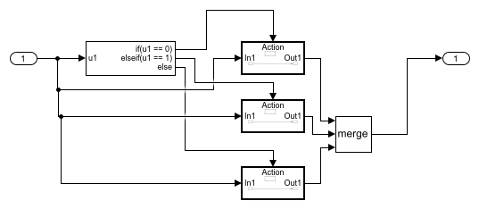

**Table 43. If Block Properties**

| **Name** | **Num Inputs** | **If Expression** | **Else If Expressions** | **Show Else** | **Zero Cross** |
| --- | --- | --- | --- | --- | --- |
| If | 1 | u1 == 0 | u1 == 1 | on | on |

**Table 44. Inport Block Properties**

| **Name** | **Port** | **Defined In Blk** |
| --- | --- | --- |
| In1 | 1 | drvr_ip |

**Table 45. Merge Block Properties**

| **Name** | **Inputs** | **Allow Unequal Input Port Widths** |
| --- | --- | --- |
| Merge | 3 | off |

**Table 46. Outport Block Properties**

| **Name** | **Port** | **Storage Class** | **Icon Display** | **Lock Scale** | **Unit** | **Var Size Sig** | **Signal Type** | **Ensure Outport Is Virtual** | **Source Of Initial Output Value** | **Output When Disabled** | **Must Resolve To Signal Object** | **Output When Un Connected** | **Output When Unconnected Value** | **Vector Params As 1DFor Out When Unconnected** | **Used By Blk** |
| --- | --- | --- | --- | --- | --- | --- | --- | --- | --- | --- | --- | --- | --- | --- | --- |
| Out1 | 1 | Auto | Port number | off | inherit | Inherit | auto | off | Dialog | held | off | off | 0 | off | Window1_status |

**System -****pwr_window_subsys_2018****/****Subsystem2****/If Action Subsystem**



**Table 47. ActionPort Block Properties**

| **Name** | **Initialize States** | **Propagate Var Size** |
| --- | --- | --- |
| Action Port | held | Only when execution is resumed |

**Table 48. Inport Block Properties**

| **Name** | **Port** | **Defined In Blk** |
| --- | --- | --- |
| In1 | 1 | drvr_ip |

**Table 49. Outport Block Properties**

| **Name** | **Port** | **Storage Class** | **Icon Display** | **Lock Scale** | **Unit** | **Var Size Sig** | **Signal Type** | **Ensure Outport Is Virtual** | **Source Of Initial Output Value** | **Output When Disabled** | **Must Resolve To Signal Object** | **Output When Un Connected** | **Output When Unconnected Value** | **Vector Params As 1DFor Out When Unconnected** | **Used By Blk** |
| --- | --- | --- | --- | --- | --- | --- | --- | --- | --- | --- | --- | --- | --- | --- | --- |
| Out1 | 1 | Auto | Port number | off | inherit | Inherit | auto | off | Dialog | held | off | off | 0 | off | Merge |

**System -****pwr_window_subsys_2018****/****Subsystem2****/If Action Subsystem1**



**Table 50. ActionPort Block Properties**

| **Name** | **Initialize States** | **Propagate Var Size** |
| --- | --- | --- |
| Action Port | held | Only when execution is resumed |

**Table 51. Inport Block Properties**

| **Name** | **Port** | **Defined In Blk** |
| --- | --- | --- |
| In1 | 1 | drvr_ip |

**Table 52. Outport Block Properties**

| **Name** | **Port** | **Storage Class** | **Icon Display** | **Lock Scale** | **Unit** | **Var Size Sig** | **Signal Type** | **Ensure Outport Is Virtual** | **Source Of Initial Output Value** | **Output When Disabled** | **Must Resolve To Signal Object** | **Output When Un Connected** | **Output When Unconnected Value** | **Vector Params As 1DFor Out When Unconnected** | **Used By Blk** |
| --- | --- | --- | --- | --- | --- | --- | --- | --- | --- | --- | --- | --- | --- | --- | --- |
| Out1 | 1 | Auto | Port number | off | inherit | Inherit | auto | off | Dialog | held | off | off | 0 | off | Merge |

**System -****pwr_window_subsys_2018****/****Subsystem2****/If Action Subsystem2**



**Table 53. ActionPort Block Properties**

| **Name** | **Initialize States** | **Propagate Var Size** |
| --- | --- | --- |
| Action Port | held | Only when execution is resumed |

**Table 54. Inport Block Properties**

| **Name** | **Port** | **Defined In Blk** |
| --- | --- | --- |
| In1 | 1 | drvr_ip |

**Table 55. Outport Block Properties**

| **Name** | **Port** | **Storage Class** | **Icon Display** | **Lock Scale** | **Unit** | **Var Size Sig** | **Signal Type** | **Ensure Outport Is Virtual** | **Source Of Initial Output Value** | **Output When Disabled** | **Must Resolve To Signal Object** | **Output When Un Connected** | **Output When Unconnected Value** | **Vector Params As 1DFor Out When Unconnected** | **Used By Blk** |
| --- | --- | --- | --- | --- | --- | --- | --- | --- | --- | --- | --- | --- | --- | --- | --- |
| Out1 | 1 | Auto | Port number | off | inherit | Inherit | auto | off | Dialog | held | off | off | 0 | off | Merge |

**System -****pwr_window_subsys_2018****/Subsystem3**

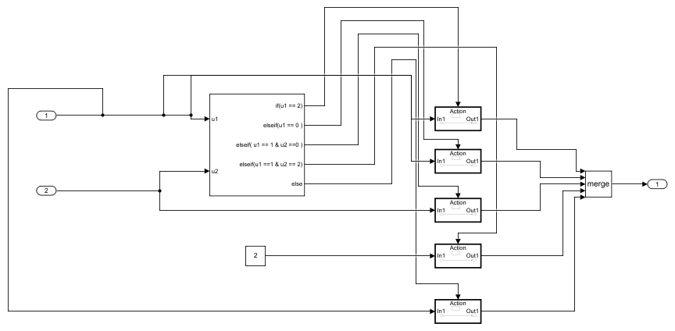

**Table 56. Constant Block Properties**

| **Name** | **Value** | **Out Data Type Str** | **Lock Scale** | **Sample Time** | **Frame Period** |
| --- | --- | --- | --- | --- | --- |
| Constant | 2 | Inherit: Inherit from 'Constant value' | off | inf | inf |

**Table 57. If Block Properties**

| **Name** | **Num Inputs** | **If Expression** | **Else If Expressions** | **Show Else** | **Zero Cross** |
| --- | --- | --- | --- | --- | --- |
| If | 2 | u1 == 2 | u1 == 0 , u1 == 1 & u2 ==0 ,u1 ==1 & u2 == 2 | on | on |

**Table 58. Inport Block Properties**

| **Name** | **Port** | **Defined In Blk** |
| --- | --- | --- |
| In1 | 1 | drivr3_ip |
| In2 | 2 | pass3_ip |

**Table 59. Merge Block Properties**

| **Name** | **Inputs** | **Allow Unequal Input Port Widths** |
| --- | --- | --- |
| Merge | 5 | off |

**Table 60. Outport Block Properties**

| **Name** | **Port** | **Storage Class** | **Icon Display** | **Lock Scale** | **Unit** | **Var Size Sig** | **Signal Type** | **Ensure Outport Is Virtual** | **Source Of Initial Output Value** | **Output When Disabled** | **Must Resolve To Signal Object** | **Output When Un Connected** | **Output When Unconnected Value** | **Vector Params As 1DFor Out When Unconnected** | **Used By Blk** |
| --- | --- | --- | --- | --- | --- | --- | --- | --- | --- | --- | --- | --- | --- | --- | --- |
| Out1 | 1 | Auto | Port number | off | inherit | Inherit | auto | off | Dialog | held | off | off | 0 | off | Window4_status |

**System -****pwr_window_subsys_2018****/****Subsystem3****/If Action Subsystem**



**Table 61. ActionPort Block Properties**

| **Name** | **Initialize States** | **Propagate Var Size** |
| --- | --- | --- |
| Action Port | held | Only when execution is resumed |

**Table 62. Inport Block Properties**

| **Name** | **Port** | **Defined In Blk** |
| --- | --- | --- |
| In1 | 1 | drivr3_ip |

**Table 63. Outport Block Properties**

| **Name** | **Port** | **Storage Class** | **Icon Display** | **Lock Scale** | **Unit** | **Var Size Sig** | **Signal Type** | **Ensure Outport Is Virtual** | **Source Of Initial Output Value** | **Output When Disabled** | **Must Resolve To Signal Object** | **Output When Un Connected** | **Output When Unconnected Value** | **Vector Params As 1DFor Out When Unconnected** | **Used By Blk** |
| --- | --- | --- | --- | --- | --- | --- | --- | --- | --- | --- | --- | --- | --- | --- | --- |
| Out1 | 1 | Auto | Port number | off | inherit | Inherit | auto | off | Dialog | held | off | off | 0 | off | Merge |

**System -****pwr_window_subsys_2018****/****Subsystem3****/If Action Subsystem1**



**Table 64. ActionPort Block Properties**

| **Name** | **Initialize States** | **Propagate Var Size** |
| --- | --- | --- |
| Action Port | held | Only when execution is resumed |

**Table 65. Inport Block Properties**

| **Name** | **Port** | **Defined In Blk** |
| --- | --- | --- |
| In1 | 1 | drivr3_ip |

**Table 66. Outport Block Properties**

| **Name** | **Port** | **Storage Class** | **Icon Display** | **Lock Scale** | **Unit** | **Var Size Sig** | **Signal Type** | **Ensure Outport Is Virtual** | **Source Of Initial Output Value** | **Output When Disabled** | **Must Resolve To Signal Object** | **Output When Un Connected** | **Output When Unconnected Value** | **Vector Params As 1DFor Out When Unconnected** | **Used By Blk** |
| --- | --- | --- | --- | --- | --- | --- | --- | --- | --- | --- | --- | --- | --- | --- | --- |
| Out1 | 1 | Auto | Port number | off | inherit | Inherit | auto | off | Dialog | held | off | off | 0 | off | Merge |

**System -****pwr_window_subsys_2018****/****Subsystem3****/If Action Subsystem2**



**Table 67. ActionPort Block Properties**

| **Name** | **Initialize States** | **Propagate Var Size** |
| --- | --- | --- |
| Action Port | held | Only when execution is resumed |

**Table 68. Inport Block Properties**

| **Name** | **Port** | **Defined In Blk** |
| --- | --- | --- |
| In1 | 1 | Constant |

**Table 69. Outport Block Properties**

| **Name** | **Port** | **Storage Class** | **Icon Display** | **Lock Scale** | **Unit** | **Var Size Sig** | **Signal Type** | **Ensure Outport Is Virtual** | **Source Of Initial Output Value** | **Output When Disabled** | **Must Resolve To Signal Object** | **Output When Un Connected** | **Output When Unconnected Value** | **Vector Params As 1DFor Out When Unconnected** | **Used By Blk** |
| --- | --- | --- | --- | --- | --- | --- | --- | --- | --- | --- | --- | --- | --- | --- | --- |
| Out1 | 1 | Auto | Port number | off | inherit | Inherit | auto | off | Dialog | held | off | off | 0 | on | Merge |

**System -****pwr_window_subsys_2018****/****Subsystem3****/If Action Subsystem3**



**Table 70. ActionPort Block Properties**

| **Name** | **Initialize States** | **Propagate Var Size** |
| --- | --- | --- |
| Action Port | held | Only when execution is resumed |

**Table 71. Inport Block Properties**

| **Name** | **Port** | **Defined In Blk** |
| --- | --- | --- |
| In1 | 1 | pass3_ip |

**Table 72. Outport Block Properties**

| **Name** | **Port** | **Storage Class** | **Icon Display** | **Lock Scale** | **Unit** | **Var Size Sig** | **Signal Type** | **Ensure Outport Is Virtual** | **Source Of Initial Output Value** | **Output When Disabled** | **Must Resolve To Signal Object** | **Output When Un Connected** | **Output When Unconnected Value** | **Vector Params As 1DFor Out When Unconnected** | **Used By Blk** |
| --- | --- | --- | --- | --- | --- | --- | --- | --- | --- | --- | --- | --- | --- | --- | --- |
| Out1 | 1 | Auto | Port number | off | inherit | Inherit | auto | off | Dialog | held | off | off | 0 | off | Merge |

**System -****pwr_window_subsys_2018****/****Subsystem3****/If Action Subsystem4**



**Table 73. ActionPort Block Properties**

| **Name** | **Initialize States** | **Propagate Var Size** |
| --- | --- | --- |
| Action Port | held | Only when execution is resumed |

**Table 74. Inport Block Properties**

| **Name** | **Port** | **Defined In Blk** |
| --- | --- | --- |
| In1 | 1 | drivr3_ip |

**Table 75. Outport Block Properties**

| **Name** | **Port** | **Storage Class** | **Icon Display** | **Lock Scale** | **Unit** | **Var Size Sig** | **Signal Type** | **Ensure Outport Is Virtual** | **Source Of Initial Output Value** | **Output When Disabled** | **Must Resolve To Signal Object** | **Output When Un Connected** | **Output When Unconnected Value** | **Vector Params As 1DFor Out When Unconnected** | **Used By Blk** |
| --- | --- | --- | --- | --- | --- | --- | --- | --- | --- | --- | --- | --- | --- | --- | --- |
| Out1 | 1 | Auto | Port number | off | inherit | Inherit | auto | off | Dialog | held | off | off | 0 | on | Merge |

**Appendix**

**Table 76. Block Type Count**

| **BlockType** | **Count** | **Block Names** |
| --- | --- | --- |
| Inport | 25 | In1, In1, In1, In1, In1, In1, In2, In1, In1, In1, In1, In1, In1, In2, In1, In1, In1, In1, In1, In1, In1, In1, In1, In1, In2 |
| SubSystem | 22 | Subsystem, If Action Subsystem, If Action Subsystem1, If Action Subsystem2, If Action Subsystem3, If Action Subsystem4, Subsystem1, If Action Subsystem, If Action Subsystem1, If Action Subsystem2, If Action Subsystem3, If Action Subsystem4, Subsystem2, If Action Subsystem, If Action Subsystem1, If Action Subsystem2, Subsystem3, If Action Subsystem, If Action Subsystem1, If Action Subsystem2, If Action Subsystem3, If Action Subsystem4 |
| Outport | 22 | Out1, Out1, Out1, Out1, Out1, Out1, Out1, Out1, Out1, Out1, Out1, Out1, Out1, Out1, Out1, Out1, Out1, Out1, Out1, Out1, Out1, Out1 |
| ActionPort | 18 | Action Port, Action Port, Action Port, Action Port, Action Port, Action Port, Action Port, Action Port, Action Port, Action Port, Action Port, Action Port, Action Port, Action Port, Action Port, Action Port, Action Port, Action Port |
| Constant | 9 | Constant, Constant, drivr1_ip, drivr2_ip, drivr3_ip, drvr_ip, pass1_ip, pass2_ip, pass3_ip |
| RotarySwitchBlock | 7 | Rotary Switch, Rotary Switch1, Rotary Switch2, Rotary Switch3, Rotary Switch4, Rotary Switch5, Rotary Switch6 |
| Merge | 4 | Merge, Merge, Merge, Merge |
| If | 4 | If, If, If, If |
| Display | 4 | Window1_status, Window2_status, Window3_status, Window4_status |

MIL Model:

**pwr_window_milmodel_2018**

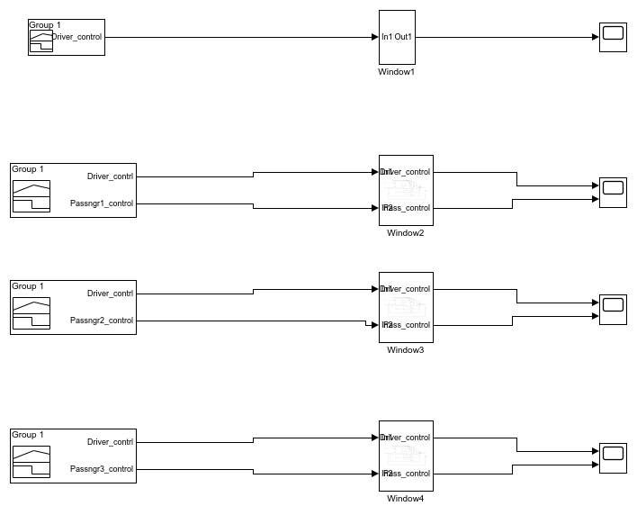

**A JOSEPH VIJAY KUMAR**

20-Dec-2020 23:02:01

**Table of Contents**

Model - pwr_window_milmodel_2018

System - pwr_window_milmodel_2018

System - pwr_window_milmodel_2018/Window1

System - pwr_window_milmodel_2018/Window1/If Action Subsystem

System - pwr_window_milmodel_2018/Window1/If Action Subsystem1

System - pwr_window_milmodel_2018/Window1/If Action Subsystem2

System - pwr_window_milmodel_2018/Window2

System - pwr_window_milmodel_2018/Window2/If Action Subsystem

System - pwr_window_milmodel_2018/Window2/If Action Subsystem1

System - pwr_window_milmodel_2018/Window2/If Action Subsystem2

System - pwr_window_milmodel_2018/Window2/If Action Subsystem3

System - pwr_window_milmodel_2018/Window2/If Action Subsystem4

System - pwr_window_milmodel_2018/Window3

System - pwr_window_milmodel_2018/Window3/If Action Subsystem

System - pwr_window_milmodel_2018/Window3/If Action Subsystem1

System - pwr_window_milmodel_2018/Window3/If Action Subsystem2

System - pwr_window_milmodel_2018/Window3/If Action Subsystem3

System - pwr_window_milmodel_2018/Window3/If Action Subsystem4

System - pwr_window_milmodel_2018/Window4

System - pwr_window_milmodel_2018/Window4/If Action Subsystem

System - pwr_window_milmodel_2018/Window4/If Action Subsystem1

System - pwr_window_milmodel_2018/Window4/If Action Subsystem2

System - pwr_window_milmodel_2018/Window4/If Action Subsystem3

System - pwr_window_milmodel_2018/Window4/If Action Subsystem4

Appendix

**List of Tables**

1. Sigbuilder block Block Properties

2. If Block Properties

3. Inport Block Properties

4. Merge Block Properties

5. Outport Block Properties

6. ActionPort Block Properties

7. Inport Block Properties

8. Outport Block Properties

9. ActionPort Block Properties

10. Inport Block Properties

11. Outport Block Properties

12. ActionPort Block Properties

13. Inport Block Properties

14. Outport Block Properties

15. Constant Block Properties

16. If Block Properties

17. Inport Block Properties

18. Merge Block Properties

19. Outport Block Properties

20. ActionPort Block Properties

21. Inport Block Properties

22. Outport Block Properties

23. ActionPort Block Properties

24. Inport Block Properties

25. Outport Block Properties

26. ActionPort Block Properties

27. Inport Block Properties

28. Outport Block Properties

29. ActionPort Block Properties

30. Inport Block Properties

31. Outport Block Properties

32. ActionPort Block Properties

33. Inport Block Properties

34. Outport Block Properties

35. Constant Block Properties

36. If Block Properties

37. Inport Block Properties

38. Merge Block Properties

39. Outport Block Properties

40. ActionPort Block Properties

41. Inport Block Properties

42. Outport Block Properties

43. ActionPort Block Properties

44. Inport Block Properties

45. Outport Block Properties

46. ActionPort Block Properties

47. Inport Block Properties

48. Outport Block Properties

49. ActionPort Block Properties

50. Inport Block Properties

51. Outport Block Properties

52. ActionPort Block Properties

53. Inport Block Properties

54. Outport Block Properties

55. Constant Block Properties

56. If Block Properties

57. Inport Block Properties

58. Merge Block Properties

59. Outport Block Properties

60. ActionPort Block Properties

61. Inport Block Properties

62. Outport Block Properties

63. ActionPort Block Properties

64. Inport Block Properties

65. Outport Block Properties

66. ActionPort Block Properties

67. Inport Block Properties

68. Outport Block Properties

69. ActionPort Block Properties

70. Inport Block Properties

71. Outport Block Properties

72. ActionPort Block Properties

73. Inport Block Properties

74. Outport Block Properties

75. Block Type Count

**Model - pwr_window_milmodel_2018**

**Full Model Hierarchy**

1. pwr_window_milmodel_2018
   1. Window1
      1. If Action Subsystem
      2. If Action Subsystem1
      3. If Action Subsystem2
   2. Window2
      1. If Action Subsystem
      2. If Action Subsystem1
      3. If Action Subsystem2
      4. If Action Subsystem3
      5. If Action Subsystem4
   3. Window3
      1. If Action Subsystem
      2. If Action Subsystem1
      3. If Action Subsystem2
      4. If Action Subsystem3
      5. If Action Subsystem4
   4. Window4
      1. If Action Subsystem
      2. If Action Subsystem1
      3. If Action Subsystem2
      4. If Action Subsystem3
      5. If Action Subsystem4

| **Simulation Parameter** | **Value** |
| --- | --- |
| Solver | VariableStepAuto |
| RelTol | 1e-3 |
| Refine | 1 |
| MaxOrder | 5 |
| ZeroCross | on |

*[more info]*

**System - pwr_window_milmodel_2018**



**Table 1. Sigbuilder block Block Properties**

| **Name** |
| --- |
| Signal Builder |
| Signal Builder1 |
| Signal Builder2 |
| Signal Builder3 |

**System -****pwr_window_milmodel_2018****/Window1**



**Table 2. If Block Properties**

| **Name** | **Num Inputs** | **If Expression** | **Else If Expressions** | **Show Else** | **Zero Cross** |
| --- | --- | --- | --- | --- | --- |
| If | 1 | u1 == 0 | u1 == 1 | on | on |

**Table 3. Inport Block Properties**

| **Name** | **Port** | **Defined In Blk** |
| --- | --- | --- |
| In1 | 1 | Demux |

**Table 4. Merge Block Properties**

| **Name** | **Inputs** | **Allow Unequal Input Port Widths** |
| --- | --- | --- |
| Merge | 3 | off |

**Table 5. Outport Block Properties**

| **Name** | **Port** | **Storage Class** | **Icon Display** | **Lock Scale** | **Unit** | **Var Size Sig** | **Signal Type** | **Ensure Outport Is Virtual** | **Source Of Initial Output Value** | **Output When Disabled** | **Must Resolve To Signal Object** | **Output When Un Connected** | **Output When Unconnected Value** | **Vector Params As 1DFor Out When Unconnected** | **Used By Blk** |
| --- | --- | --- | --- | --- | --- | --- | --- | --- | --- | --- | --- | --- | --- | --- | --- |
| Out1 | 1 | Auto | Port number | off | inherit | Inherit | auto | off | Dialog | held | off | off | 0 | off | Scope |

**System -****pwr_window_milmodel_2018****/****Window1****/If Action Subsystem**



**Table 6. ActionPort Block Properties**

| **Name** | **Initialize States** | **Propagate Var Size** |
| --- | --- | --- |
| Action Port | held | Only when execution is resumed |

**Table 7. Inport Block Properties**

| **Name** | **Port** | **Defined In Blk** |
| --- | --- | --- |
| In1 | 1 | Demux |

**Table 8. Outport Block Properties**

| **Name** | **Port** | **Storage Class** | **Icon Display** | **Lock Scale** | **Unit** | **Var Size Sig** | **Signal Type** | **Ensure Outport Is Virtual** | **Source Of Initial Output Value** | **Output When Disabled** | **Must Resolve To Signal Object** | **Output When Un Connected** | **Output When Unconnected Value** | **Vector Params As 1DFor Out When Unconnected** | **Used By Blk** |
| --- | --- | --- | --- | --- | --- | --- | --- | --- | --- | --- | --- | --- | --- | --- | --- |
| Out1 | 1 | Auto | Port number | off | inherit | Inherit | auto | off | Dialog | held | off | off | 0 | off | Merge |

**System -****pwr_window_milmodel_2018****/****Window1****/If Action Subsystem1**



**Table 9. ActionPort Block Properties**

| **Name** | **Initialize States** | **Propagate Var Size** |
| --- | --- | --- |
| Action Port | held | Only when execution is resumed |

**Table 10. Inport Block Properties**

| **Name** | **Port** | **Defined In Blk** |
| --- | --- | --- |
| In1 | 1 | Demux |

**Table 11. Outport Block Properties**

| **Name** | **Port** | **Storage Class** | **Icon Display** | **Lock Scale** | **Unit** | **Var Size Sig** | **Signal Type** | **Ensure Outport Is Virtual** | **Source Of Initial Output Value** | **Output When Disabled** | **Must Resolve To Signal Object** | **Output When Un Connected** | **Output When Unconnected Value** | **Vector Params As 1DFor Out When Unconnected** | **Used By Blk** |
| --- | --- | --- | --- | --- | --- | --- | --- | --- | --- | --- | --- | --- | --- | --- | --- |
| Out1 | 1 | Auto | Port number | off | inherit | Inherit | auto | off | Dialog | held | off | off | 0 | off | Merge |

**System -****pwr_window_milmodel_2018****/****Window1****/If Action Subsystem2**



**Table 12. ActionPort Block Properties**

| **Name** | **Initialize States** | **Propagate Var Size** |
| --- | --- | --- |
| Action Port | held | Only when execution is resumed |

**Table 13. Inport Block Properties**

| **Name** | **Port** | **Defined In Blk** |
| --- | --- | --- |
| In1 | 1 | Demux |

**Table 14. Outport Block Properties**

| **Name** | **Port** | **Storage Class** | **Icon Display** | **Lock Scale** | **Unit** | **Var Size Sig** | **Signal Type** | **Ensure Outport Is Virtual** | **Source Of Initial Output Value** | **Output When Disabled** | **Must Resolve To Signal Object** | **Output When Un Connected** | **Output When Unconnected Value** | **Vector Params As 1DFor Out When Unconnected** | **Used By Blk** |
| --- | --- | --- | --- | --- | --- | --- | --- | --- | --- | --- | --- | --- | --- | --- | --- |
| Out1 | 1 | Auto | Port number | off | inherit | Inherit | auto | off | Dialog | held | off | off | 0 | off | Merge |

**System -****pwr_window_milmodel_2018****/Window2**

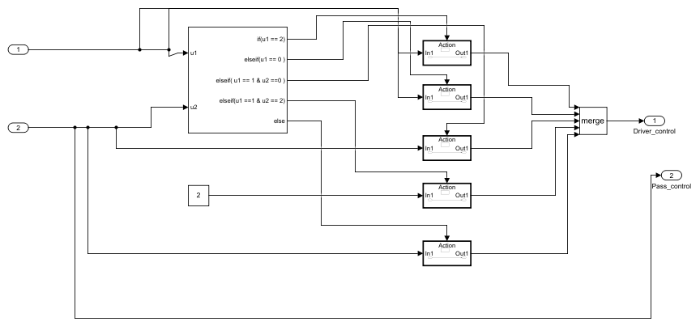

**Table 15. Constant Block Properties**

| **Name** | **Value** | **Out Data Type Str** | **Lock Scale** | **Sample Time** | **Frame Period** |
| --- | --- | --- | --- | --- | --- |
| Constant | 2 | Inherit: Inherit from 'Constant value' | off | inf | inf |

**Table 16. If Block Properties**

| **Name** | **Num Inputs** | **If Expression** | **Else If Expressions** | **Show Else** | **Zero Cross** |
| --- | --- | --- | --- | --- | --- |
| If | 2 | u1 == 2 | u1 == 0 , u1 == 1 & u2 ==0 ,u1 ==1 & u2 == 2 | on | on |

**Table 17. Inport Block Properties**

| **Name** | **Port** | **Defined In Blk** |
| --- | --- | --- |
| In1 | 1 | Demux |
| In2 | 2 | Demux |

**Table 18. Merge Block Properties**

| **Name** | **Inputs** | **Allow Unequal Input Port Widths** |
| --- | --- | --- |
| Merge | 5 | off |

**Table 19. Outport Block Properties**

| **Name** | **Port** | **Storage Class** | **Icon Display** | **Lock Scale** | **Unit** | **Var Size Sig** | **Signal Type** | **Ensure Outport Is Virtual** | **Source Of Initial Output Value** | **Output When Disabled** | **Must Resolve To Signal Object** | **Output When Un Connected** | **Output When Unconnected Value** | **Vector Params As 1DFor Out When Unconnected** | **Used By Blk** |
| --- | --- | --- | --- | --- | --- | --- | --- | --- | --- | --- | --- | --- | --- | --- | --- |
| Driver_control | 1 | Auto | Port number | off | inherit | Inherit | auto | off | Dialog | held | off | off | 0 | off | Scope1 |
| Pass_control | 2 | Auto | Port number | off | inherit | Inherit | auto | off | Dialog | held | off | off | 0 | on | Merge, Merge, Scope1, If |

**System -****pwr_window_milmodel_2018****/****Window2****/If Action Subsystem**



**Table 20. ActionPort Block Properties**

| **Name** | **Initialize States** | **Propagate Var Size** |
| --- | --- | --- |
| Action Port | held | Only when execution is resumed |

**Table 21. Inport Block Properties**

| **Name** | **Port** | **Defined In Blk** |
| --- | --- | --- |
| In1 | 1 | Demux |

**Table 22. Outport Block Properties**

| **Name** | **Port** | **Storage Class** | **Icon Display** | **Lock Scale** | **Unit** | **Var Size Sig** | **Signal Type** | **Ensure Outport Is Virtual** | **Source Of Initial Output Value** | **Output When Disabled** | **Must Resolve To Signal Object** | **Output When Un Connected** | **Output When Unconnected Value** | **Vector Params As 1DFor Out When Unconnected** | **Used By Blk** |
| --- | --- | --- | --- | --- | --- | --- | --- | --- | --- | --- | --- | --- | --- | --- | --- |
| Out1 | 1 | Auto | Port number | off | inherit | Inherit | auto | off | Dialog | held | off | off | 0 | off | Merge |

**System -****pwr_window_milmodel_2018****/****Window2****/If Action Subsystem1**



**Table 23. ActionPort Block Properties**

| **Name** | **Initialize States** | **Propagate Var Size** |
| --- | --- | --- |
| Action Port | held | Only when execution is resumed |

**Table 24. Inport Block Properties**

| **Name** | **Port** | **Defined In Blk** |
| --- | --- | --- |
| In1 | 1 | Demux |

**Table 25. Outport Block Properties**

| **Name** | **Port** | **Storage Class** | **Icon Display** | **Lock Scale** | **Unit** | **Var Size Sig** | **Signal Type** | **Ensure Outport Is Virtual** | **Source Of Initial Output Value** | **Output When Disabled** | **Must Resolve To Signal Object** | **Output When Un Connected** | **Output When Unconnected Value** | **Vector Params As 1DFor Out When Unconnected** | **Used By Blk** |
| --- | --- | --- | --- | --- | --- | --- | --- | --- | --- | --- | --- | --- | --- | --- | --- |
| Out1 | 1 | Auto | Port number | off | inherit | Inherit | auto | off | Dialog | held | off | off | 0 | off | Merge |

**System -****pwr_window_milmodel_2018****/****Window2****/If Action Subsystem2**



**Table 26. ActionPort Block Properties**

| **Name** | **Initialize States** | **Propagate Var Size** |
| --- | --- | --- |
| Action Port | held | Only when execution is resumed |

**Table 27. Inport Block Properties**

| **Name** | **Port** | **Defined In Blk** |
| --- | --- | --- |
| In1 | 1 | Constant |

**Table 28. Outport Block Properties**

| **Name** | **Port** | **Storage Class** | **Icon Display** | **Lock Scale** | **Unit** | **Var Size Sig** | **Signal Type** | **Ensure Outport Is Virtual** | **Source Of Initial Output Value** | **Output When Disabled** | **Must Resolve To Signal Object** | **Output When Un Connected** | **Output When Unconnected Value** | **Vector Params As 1DFor Out When Unconnected** | **Used By Blk** |
| --- | --- | --- | --- | --- | --- | --- | --- | --- | --- | --- | --- | --- | --- | --- | --- |
| Out1 | 1 | Auto | Port number | off | inherit | Inherit | auto | off | Dialog | held | off | off | 0 | on | Merge |

**System -****pwr_window_milmodel_2018****/****Window2****/If Action Subsystem3**



**Table 29. ActionPort Block Properties**

| **Name** | **Initialize States** | **Propagate Var Size** |
| --- | --- | --- |
| Action Port | held | Only when execution is resumed |

**Table 30. Inport Block Properties**

| **Name** | **Port** | **Defined In Blk** |
| --- | --- | --- |
| In1 | 1 | Demux |

**Table 31. Outport Block Properties**

| **Name** | **Port** | **Storage Class** | **Icon Display** | **Lock Scale** | **Unit** | **Var Size Sig** | **Signal Type** | **Ensure Outport Is Virtual** | **Source Of Initial Output Value** | **Output When Disabled** | **Must Resolve To Signal Object** | **Output When Un Connected** | **Output When Unconnected Value** | **Vector Params As 1DFor Out When Unconnected** | **Used By Blk** |
| --- | --- | --- | --- | --- | --- | --- | --- | --- | --- | --- | --- | --- | --- | --- | --- |
| Out1 | 1 | Auto | Port number | off | inherit | Inherit | auto | off | Dialog | held | off | off | 0 | off | Merge |

**System -****pwr_window_milmodel_2018****/****Window2****/If Action Subsystem4**



**Table 32. ActionPort Block Properties**

| **Name** | **Initialize States** | **Propagate Var Size** |
| --- | --- | --- |
| Action Port | held | Only when execution is resumed |

**Table 33. Inport Block Properties**

| **Name** | **Port** | **Defined In Blk** |
| --- | --- | --- |
| In1 | 1 | Demux |

**Table 34. Outport Block Properties**

| **Name** | **Port** | **Storage Class** | **Icon Display** | **Lock Scale** | **Unit** | **Var Size Sig** | **Signal Type** | **Ensure Outport Is Virtual** | **Source Of Initial Output Value** | **Output When Disabled** | **Must Resolve To Signal Object** | **Output When Un Connected** | **Output When Unconnected Value** | **Vector Params As 1DFor Out When Unconnected** | **Used By Blk** |
| --- | --- | --- | --- | --- | --- | --- | --- | --- | --- | --- | --- | --- | --- | --- | --- |
| Out1 | 1 | Auto | Port number | off | inherit | Inherit | auto | off | Dialog | held | off | off | 0 | on | Merge |

**System -****pwr_window_milmodel_2018****/Window3**

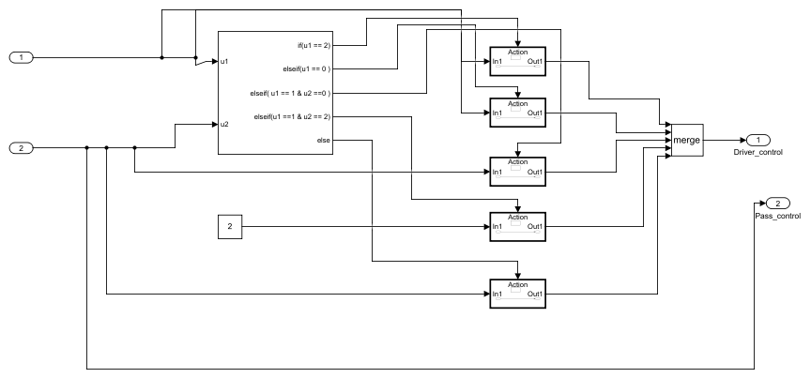

**Table 35. Constant Block Properties**

| **Name** | **Value** | **Out Data Type Str** | **Lock Scale** | **Sample Time** | **Frame Period** |
| --- | --- | --- | --- | --- | --- |
| Constant | 2 | Inherit: Inherit from 'Constant value' | off | inf | inf |

**Table 36. If Block Properties**

| **Name** | **Num Inputs** | **If Expression** | **Else If Expressions** | **Show Else** | **Zero Cross** |
| --- | --- | --- | --- | --- | --- |
| If | 2 | u1 == 2 | u1 == 0 , u1 == 1 & u2 ==0 ,u1 ==1 & u2 == 2 | on | on |

**Table 37. Inport Block Properties**

| **Name** | **Port** | **Defined In Blk** |
| --- | --- | --- |
| In1 | 1 | Demux |
| In2 | 2 | Demux |

**Table 38. Merge Block Properties**

| **Name** | **Inputs** | **Allow Unequal Input Port Widths** |
| --- | --- | --- |
| Merge | 5 | off |

**Table 39. Outport Block Properties**

| **Name** | **Port** | **Storage Class** | **Icon Display** | **Lock Scale** | **Unit** | **Var Size Sig** | **Signal Type** | **Ensure Outport Is Virtual** | **Source Of Initial Output Value** | **Output When Disabled** | **Must Resolve To Signal Object** | **Output When Un Connected** | **Output When Unconnected Value** | **Vector Params As 1DFor Out When Unconnected** | **Used By Blk** |
| --- | --- | --- | --- | --- | --- | --- | --- | --- | --- | --- | --- | --- | --- | --- | --- |
| Driver_control | 1 | Auto | Port number | off | inherit | Inherit | auto | off | Dialog | held | off | off | 0 | off | Scope2 |
| Pass_control | 2 | Auto | Port number | off | inherit | Inherit | auto | off | Dialog | held | off | off | 0 | on | Merge, Merge, Scope2, If |

**System -****pwr_window_milmodel_2018****/****Window3****/If Action Subsystem**



**Table 40. ActionPort Block Properties**

| **Name** | **Initialize States** | **Propagate Var Size** |
| --- | --- | --- |
| Action Port | held | Only when execution is resumed |

**Table 41. Inport Block Properties**

| **Name** | **Port** | **Defined In Blk** |
| --- | --- | --- |
| In1 | 1 | Demux |

**Table 42. Outport Block Properties**

| **Name** | **Port** | **Storage Class** | **Icon Display** | **Lock Scale** | **Unit** | **Var Size Sig** | **Signal Type** | **Ensure Outport Is Virtual** | **Source Of Initial Output Value** | **Output When Disabled** | **Must Resolve To Signal Object** | **Output When Un Connected** | **Output When Unconnected Value** | **Vector Params As 1DFor Out When Unconnected** | **Used By Blk** |
| --- | --- | --- | --- | --- | --- | --- | --- | --- | --- | --- | --- | --- | --- | --- | --- |
| Out1 | 1 | Auto | Port number | off | inherit | Inherit | auto | off | Dialog | held | off | off | 0 | off | Merge |

**System -****pwr_window_milmodel_2018****/****Window3****/If Action Subsystem1**



**Table 43. ActionPort Block Properties**

| **Name** | **Initialize States** | **Propagate Var Size** |
| --- | --- | --- |
| Action Port | held | Only when execution is resumed |

**Table 44. Inport Block Properties**

| **Name** | **Port** | **Defined In Blk** |
| --- | --- | --- |
| In1 | 1 | Demux |

**Table 45. Outport Block Properties**

| **Name** | **Port** | **Storage Class** | **Icon Display** | **Lock Scale** | **Unit** | **Var Size Sig** | **Signal Type** | **Ensure Outport Is Virtual** | **Source Of Initial Output Value** | **Output When Disabled** | **Must Resolve To Signal Object** | **Output When Un Connected** | **Output When Unconnected Value** | **Vector Params As 1DFor Out When Unconnected** | **Used By Blk** |
| --- | --- | --- | --- | --- | --- | --- | --- | --- | --- | --- | --- | --- | --- | --- | --- |
| Out1 | 1 | Auto | Port number | off | inherit | Inherit | auto | off | Dialog | held | off | off | 0 | off | Merge |

**System -****pwr_window_milmodel_2018****/****Window3****/If Action Subsystem2**



**Table 46. ActionPort Block Properties**

| **Name** | **Initialize States** | **Propagate Var Size** |
| --- | --- | --- |
| Action Port | held | Only when execution is resumed |

**Table 47. Inport Block Properties**

| **Name** | **Port** | **Defined In Blk** |
| --- | --- | --- |
| In1 | 1 | Constant |

**Table 48. Outport Block Properties**

| **Name** | **Port** | **Storage Class** | **Icon Display** | **Lock Scale** | **Unit** | **Var Size Sig** | **Signal Type** | **Ensure Outport Is Virtual** | **Source Of Initial Output Value** | **Output When Disabled** | **Must Resolve To Signal Object** | **Output When Un Connected** | **Output When Unconnected Value** | **Vector Params As 1DFor Out When Unconnected** | **Used By Blk** |
| --- | --- | --- | --- | --- | --- | --- | --- | --- | --- | --- | --- | --- | --- | --- | --- |
| Out1 | 1 | Auto | Port number | off | inherit | Inherit | auto | off | Dialog | held | off | off | 0 | on | Merge |

**System -****pwr_window_milmodel_2018****/****Window3****/If Action Subsystem3**



**Table 49. ActionPort Block Properties**

| **Name** | **Initialize States** | **Propagate Var Size** |
| --- | --- | --- |
| Action Port | held | Only when execution is resumed |

**Table 50. Inport Block Properties**

| **Name** | **Port** | **Defined In Blk** |
| --- | --- | --- |
| In1 | 1 | Demux |

**Table 51. Outport Block Properties**

| **Name** | **Port** | **Storage Class** | **Icon Display** | **Lock Scale** | **Unit** | **Var Size Sig** | **Signal Type** | **Ensure Outport Is Virtual** | **Source Of Initial Output Value** | **Output When Disabled** | **Must Resolve To Signal Object** | **Output When Un Connected** | **Output When Unconnected Value** | **Vector Params As 1DFor Out When Unconnected** | **Used By Blk** |
| --- | --- | --- | --- | --- | --- | --- | --- | --- | --- | --- | --- | --- | --- | --- | --- |
| Out1 | 1 | Auto | Port number | off | inherit | Inherit | auto | off | Dialog | held | off | off | 0 | off | Merge |

**System -****pwr_window_milmodel_2018****/****Window3****/If Action Subsystem4**



**Table 52. ActionPort Block Properties**

| **Name** | **Initialize States** | **Propagate Var Size** |
| --- | --- | --- |
| Action Port | held | Only when execution is resumed |

**Table 53. Inport Block Properties**

| **Name** | **Port** | **Defined In Blk** |
| --- | --- | --- |
| In1 | 1 | Demux |

**Table 54. Outport Block Properties**

| **Name** | **Port** | **Storage Class** | **Icon Display** | **Lock Scale** | **Unit** | **Var Size Sig** | **Signal Type** | **Ensure Outport Is Virtual** | **Source Of Initial Output Value** | **Output When Disabled** | **Must Resolve To Signal Object** | **Output When Un Connected** | **Output When Unconnected Value** | **Vector Params As 1DFor Out When Unconnected** | **Used By Blk** |
| --- | --- | --- | --- | --- | --- | --- | --- | --- | --- | --- | --- | --- | --- | --- | --- |
| Out1 | 1 | Auto | Port number | off | inherit | Inherit | auto | off | Dialog | held | off | off | 0 | on | Merge |

**System -****pwr_window_milmodel_2018****/Window4**

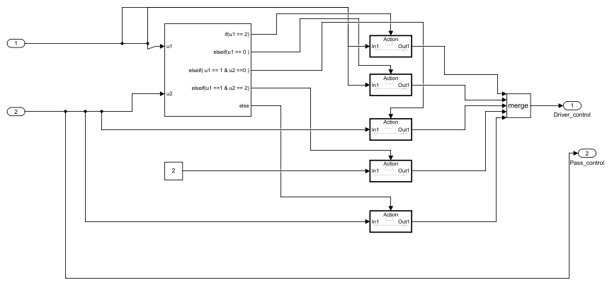

**Table 55. Constant Block Properties**

| **Name** | **Value** | **Out Data Type Str** | **Lock Scale** | **Sample Time** | **Frame Period** |
| --- | --- | --- | --- | --- | --- |
| Constant | 2 | Inherit: Inherit from 'Constant value' | off | inf | inf |

**Table 56. If Block Properties**

| **Name** | **Num Inputs** | **If Expression** | **Else If Expressions** | **Show Else** | **Zero Cross** |
| --- | --- | --- | --- | --- | --- |
| If | 2 | u1 == 2 | u1 == 0 , u1 == 1 & u2 ==0 ,u1 ==1 & u2 == 2 | on | on |

**Table 57. Inport Block Properties**

| **Name** | **Port** | **Defined In Blk** |
| --- | --- | --- |
| In1 | 1 | Demux |
| In2 | 2 | Demux |

**Table 58. Merge Block Properties**

| **Name** | **Inputs** | **Allow Unequal Input Port Widths** |
| --- | --- | --- |
| Merge | 5 | off |

**Table 59. Outport Block Properties**

| **Name** | **Port** | **Storage Class** | **Icon Display** | **Lock Scale** | **Unit** | **Var Size Sig** | **Signal Type** | **Ensure Outport Is Virtual** | **Source Of Initial Output Value** | **Output When Disabled** | **Must Resolve To Signal Object** | **Output When Un Connected** | **Output When Unconnected Value** | **Vector Params As 1DFor Out When Unconnected** | **Used By Blk** |
| --- | --- | --- | --- | --- | --- | --- | --- | --- | --- | --- | --- | --- | --- | --- | --- |
| Driver_control | 1 | Auto | Port number | off | inherit | Inherit | auto | off | Dialog | held | off | off | 0 | off | Scope3 |
| Pass_control | 2 | Auto | Port number | off | inherit | Inherit | auto | off | Dialog | held | off | off | 0 | on | Merge, Merge, Scope3, If |

**System -****pwr_window_milmodel_2018****/****Window4****/If Action Subsystem**



**Table 60. ActionPort Block Properties**

| **Name** | **Initialize States** | **Propagate Var Size** |
| --- | --- | --- |
| Action Port | held | Only when execution is resumed |

**Table 61. Inport Block Properties**

| **Name** | **Port** | **Defined In Blk** |
| --- | --- | --- |
| In1 | 1 | Demux |

**Table 62. Outport Block Properties**

| **Name** | **Port** | **Storage Class** | **Icon Display** | **Lock Scale** | **Unit** | **Var Size Sig** | **Signal Type** | **Ensure Outport Is Virtual** | **Source Of Initial Output Value** | **Output When Disabled** | **Must Resolve To Signal Object** | **Output When Un Connected** | **Output When Unconnected Value** | **Vector Params As 1DFor Out When Unconnected** | **Used By Blk** |
| --- | --- | --- | --- | --- | --- | --- | --- | --- | --- | --- | --- | --- | --- | --- | --- |
| Out1 | 1 | Auto | Port number | off | inherit | Inherit | auto | off | Dialog | held | off | off | 0 | off | Merge |

**System -****pwr_window_milmodel_2018****/****Window4****/If Action Subsystem1**



**Table 63. ActionPort Block Properties**

| **Name** | **Initialize States** | **Propagate Var Size** |
| --- | --- | --- |
| Action Port | held | Only when execution is resumed |

**Table 64. Inport Block Properties**

| **Name** | **Port** | **Defined In Blk** |
| --- | --- | --- |
| In1 | 1 | Demux |

**Table 65. Outport Block Properties**

| **Name** | **Port** | **Storage Class** | **Icon Display** | **Lock Scale** | **Unit** | **Var Size Sig** | **Signal Type** | **Ensure Outport Is Virtual** | **Source Of Initial Output Value** | **Output When Disabled** | **Must Resolve To Signal Object** | **Output When Un Connected** | **Output When Unconnected Value** | **Vector Params As 1DFor Out When Unconnected** | **Used By Blk** |
| --- | --- | --- | --- | --- | --- | --- | --- | --- | --- | --- | --- | --- | --- | --- | --- |
| Out1 | 1 | Auto | Port number | off | inherit | Inherit | auto | off | Dialog | held | off | off | 0 | off | Merge |

**System -****pwr_window_milmodel_2018****/****Window4****/If Action Subsystem2**



**Table 66. ActionPort Block Properties**

| **Name** | **Initialize States** | **Propagate Var Size** |
| --- | --- | --- |
| Action Port | held | Only when execution is resumed |

**Table 67. Inport Block Properties**

| **Name** | **Port** | **Defined In Blk** |
| --- | --- | --- |
| In1 | 1 | Constant |

**Table 68. Outport Block Properties**

| **Name** | **Port** | **Storage Class** | **Icon Display** | **Lock Scale** | **Unit** | **Var Size Sig** | **Signal Type** | **Ensure Outport Is Virtual** | **Source Of Initial Output Value** | **Output When Disabled** | **Must Resolve To Signal Object** | **Output When Un Connected** | **Output When Unconnected Value** | **Vector Params As 1DFor Out When Unconnected** | **Used By Blk** |
| --- | --- | --- | --- | --- | --- | --- | --- | --- | --- | --- | --- | --- | --- | --- | --- |
| Out1 | 1 | Auto | Port number | off | inherit | Inherit | auto | off | Dialog | held | off | off | 0 | on | Merge |

**System -****pwr_window_milmodel_2018****/****Window4****/If Action Subsystem3**



**Table 69. ActionPort Block Properties**

| **Name** | **Initialize States** | **Propagate Var Size** |
| --- | --- | --- |
| Action Port | held | Only when execution is resumed |

**Table 70. Inport Block Properties**

| **Name** | **Port** | **Defined In Blk** |
| --- | --- | --- |
| In1 | 1 | Demux |

**Table 71. Outport Block Properties**

| **Name** | **Port** | **Storage Class** | **Icon Display** | **Lock Scale** | **Unit** | **Var Size Sig** | **Signal Type** | **Ensure Outport Is Virtual** | **Source Of Initial Output Value** | **Output When Disabled** | **Must Resolve To Signal Object** | **Output When Un Connected** | **Output When Unconnected Value** | **Vector Params As 1DFor Out When Unconnected** | **Used By Blk** |
| --- | --- | --- | --- | --- | --- | --- | --- | --- | --- | --- | --- | --- | --- | --- | --- |
| Out1 | 1 | Auto | Port number | off | inherit | Inherit | auto | off | Dialog | held | off | off | 0 | off | Merge |

**System -****pwr_window_milmodel_2018****/****Window4****/If Action Subsystem4**



**Table 72. ActionPort Block Properties**

| **Name** | **Initialize States** | **Propagate Var Size** |
| --- | --- | --- |
| Action Port | held | Only when execution is resumed |

**Table 73. Inport Block Properties**

| **Name** | **Port** | **Defined In Blk** |
| --- | --- | --- |
| In1 | 1 | Demux |

**Table 74. Outport Block Properties**

| **Name** | **Port** | **Storage Class** | **Icon Display** | **Lock Scale** | **Unit** | **Var Size Sig** | **Signal Type** | **Ensure Outport Is Virtual** | **Source Of Initial Output Value** | **Output When Disabled** | **Must Resolve To Signal Object** | **Output When Un Connected** | **Output When Unconnected Value** | **Vector Params As 1DFor Out When Unconnected** | **Used By Blk** |
| --- | --- | --- | --- | --- | --- | --- | --- | --- | --- | --- | --- | --- | --- | --- | --- |
| Out1 | 1 | Auto | Port number | off | inherit | Inherit | auto | off | Dialog | held | off | off | 0 | on | Merge |

**Appendix**

**Table 75. Block Type Count**

| **BlockType** | **Count** | **Block Names** |
| --- | --- | --- |
| Outport | 25 | Out1, Out1, Out1, Out1, Driver_control, Out1, Out1, Out1, Out1, Out1, Pass_control, Driver_control, Out1, Out1, Out1, Out1, Out1, Pass_control, Driver_control, Out1, Out1, Out1, Out1, Out1, Pass_control |
| Inport | 25 | In1, In1, In1, In1, In1, In1, In1, In1, In1, In1, In2, In1, In1, In1, In1, In1, In1, In2, In1, In1, In1, In1, In1, In1, In2 |
| SubSystem | 22 | Window1, If Action Subsystem, If Action Subsystem1, If Action Subsystem2, Window2, If Action Subsystem, If Action Subsystem1, If Action Subsystem2, If Action Subsystem3, If Action Subsystem4, Window3, If Action Subsystem, If Action Subsystem1, If Action Subsystem2, If Action Subsystem3, If Action Subsystem4, Window4, If Action Subsystem, If Action Subsystem1, If Action Subsystem2, If Action Subsystem3, If Action Subsystem4 |
| ActionPort | 18 | Action Port, Action Port, Action Port, Action Port, Action Port, Action Port, Action Port, Action Port, Action Port, Action Port, Action Port, Action Port, Action Port, Action Port, Action Port, Action Port, Action Port, Action Port |
| Sigbuilder block (m) | 4 | Signal Builder, Signal Builder1, Signal Builder2, Signal Builder3 |
| Scope | 4 | Scope, Scope1, Scope2, Scope3 |
| Merge | 4 | Merge, Merge, Merge, Merge |
| If | 4 | If, If, If, If |
| Constant | 3 | Constant, Constant, Constant |

**References:**

Video references:

1. <https://www.youtube.com/watch?v=vsWFcMGk-no>
2. <https://www.youtube.com/watch?v=kJMzXGygLRc>

Reference Websites:

1. <https://en.wikipedia.org/wiki/Power_window>

2)[https://in.mathworks.com/help/simulink/ug/power-window-example-case- study.html](https://in.mathworks.com/help/simulink/ug/power-window-example-case-%20%20study.html)

**APPENDIX**

**MAT Lab Onramp Certificate:**



**Course Completion Certificate**

Joseph Vijay Kumar

has successfully completed 100% of the self-paced training course

MATLAB Onramp

14

December

2020

**Simulink Onramp Certificate:**



**Course Completion Certificate**

Joseph Vijay Kumar

has successfully completed 100% of the self-paced training course

Simulink Onramp

15

December

2020

**State-flow Onramp:**



**Course Completion Certificate**

Joseph Vijay Kumar

has successfully completed 100% of the self-paced training course

Stateflow Onramp

17

December

2020